ELK

Complete by: Nikita Prohcarau

Git: https://github.com/Nikita-Prohorov/observability_module

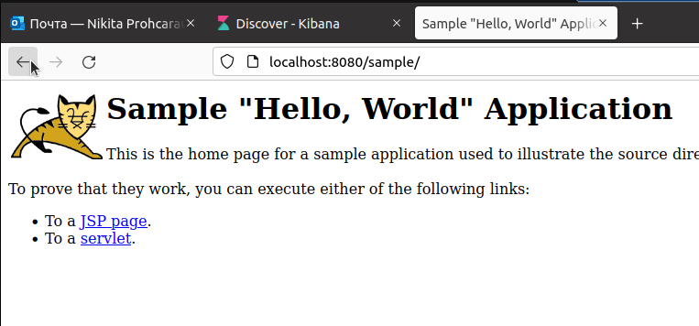

State tomcat after start system

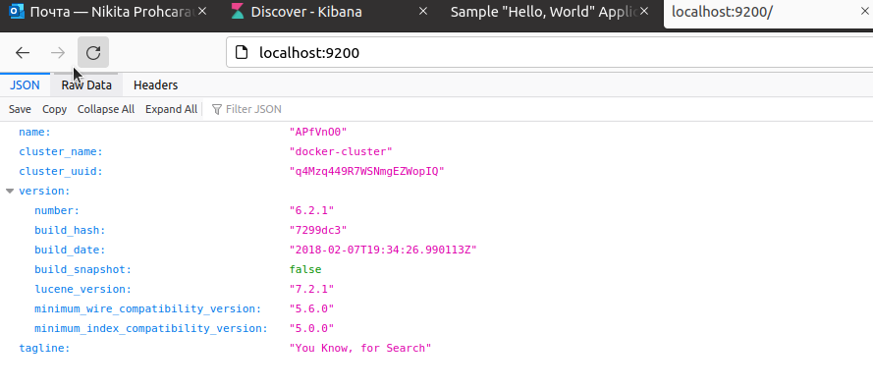

State Elasticsearch after start system

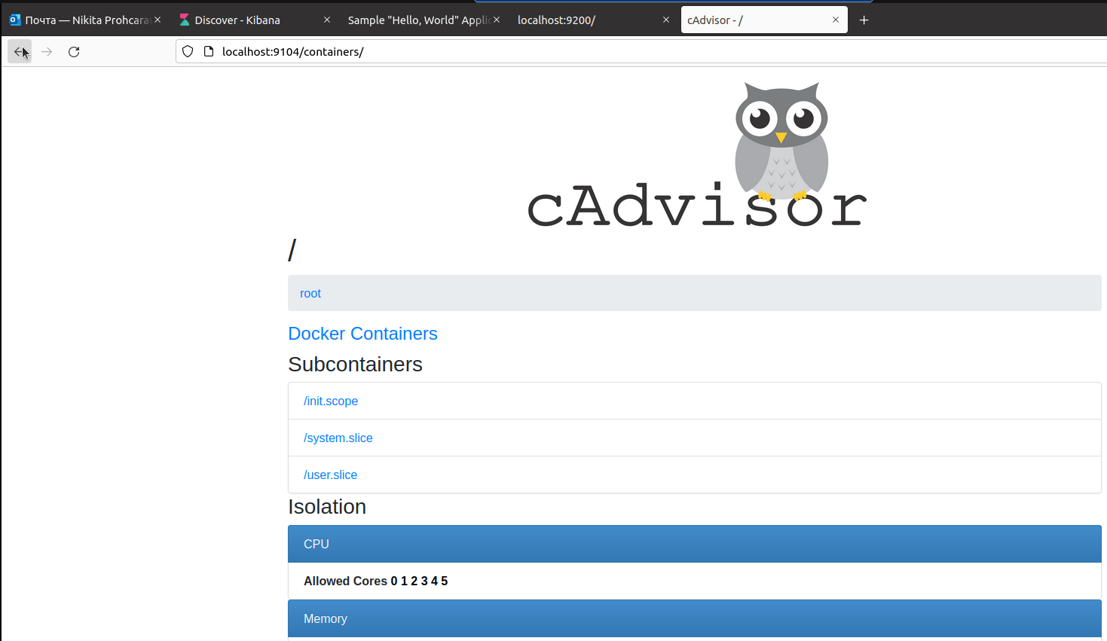

State Monitoring system after start system

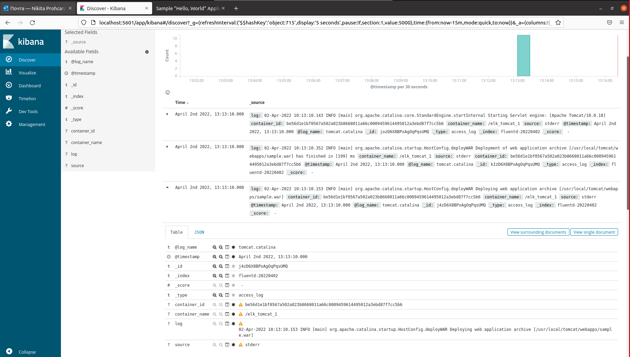

Log tomcat.catalina start Deployment

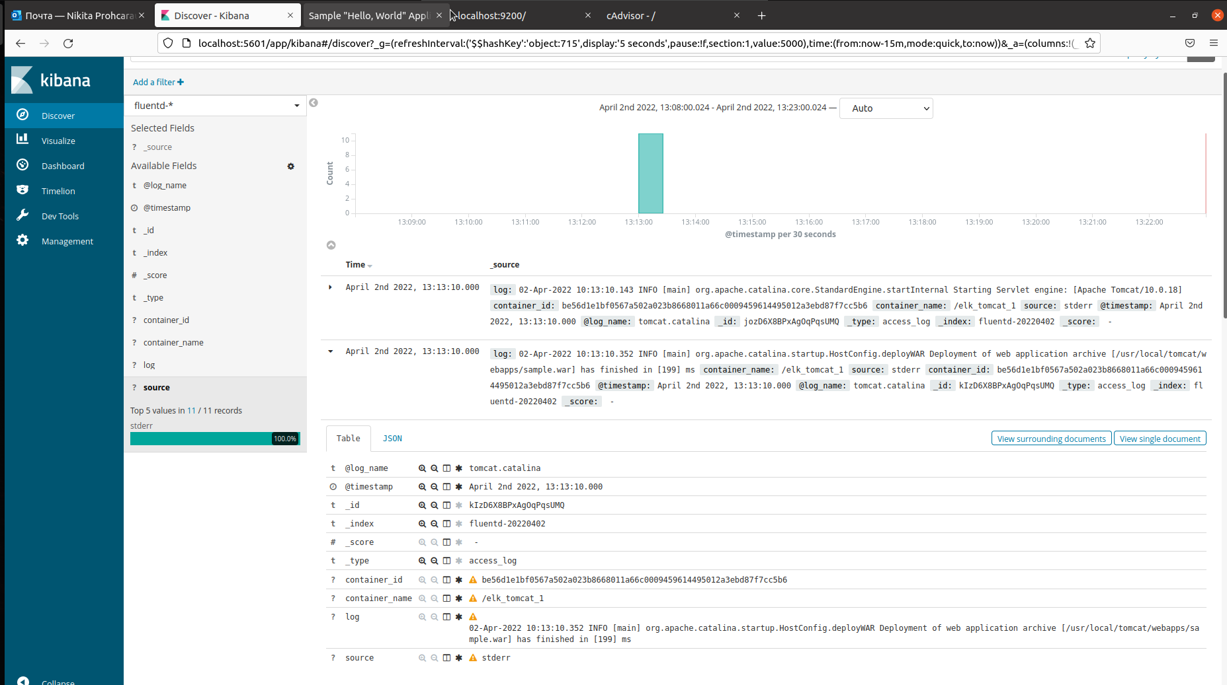

Log tomcat.catalina end Deployment

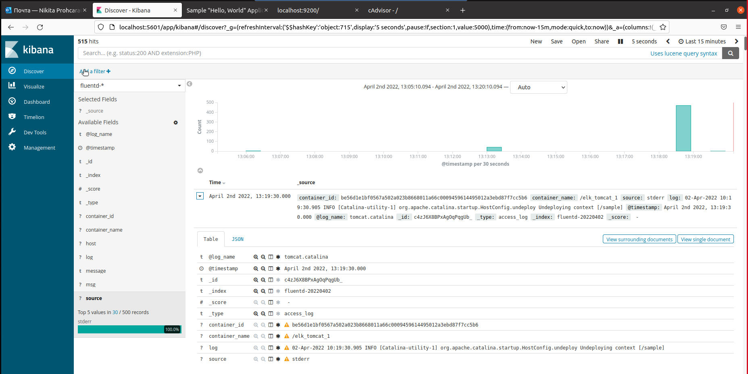

Undeployment log tomcat.catalina after delete “sample.war”